**Looking For Concerts**

**User Manual**

Changes

|  |  |
| --- | --- |
| 2.1.2018 | User manual has been released. |

Contents

A. Web application guide

1. Non-registered user

a- Homepage

b- Log in page

c- Sign up page

d- Concert page

e- User page

2. Registered user

a- Homepage

b- Concert page

c- User page

d- Create a concert page

e- Edit profile page

f- Report a concert page

g- User’s own page

B. Android application guide

1. **Web application guide**
2. **Non-registered user**

**a- Homepage**

All users can view the home page simply by navigating to the address of the website.

Here non-registered users can view concerts, search concerts or sign up.

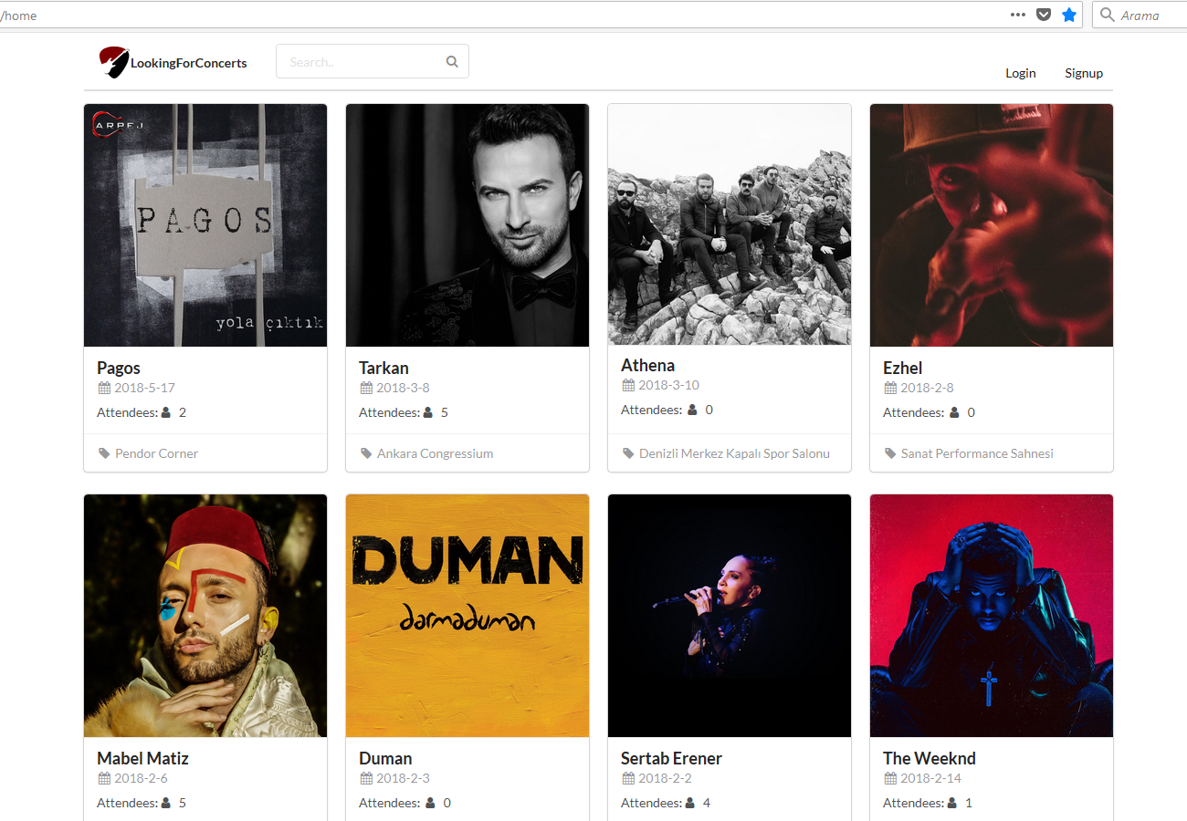

**b- Login page**

After signing up the user can login to the application.

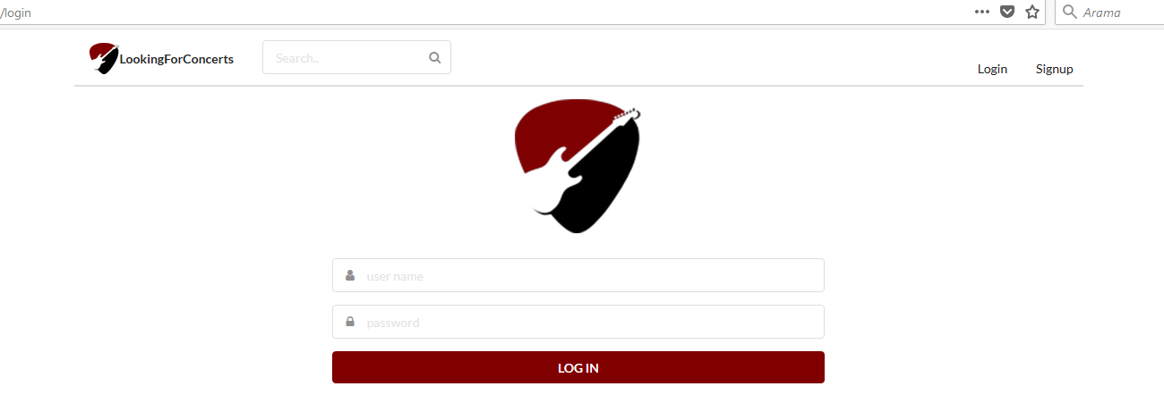

**c- Signup Page**

Before logging in, the users need to sign up by filling out the following form.

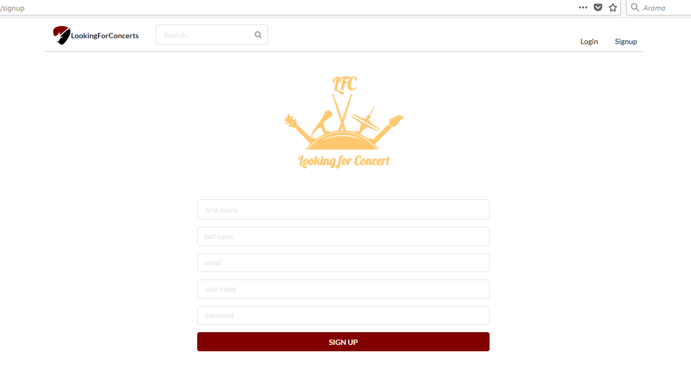

**d- Concert Page**

The user can view details of a concert by clicking them on the home page.

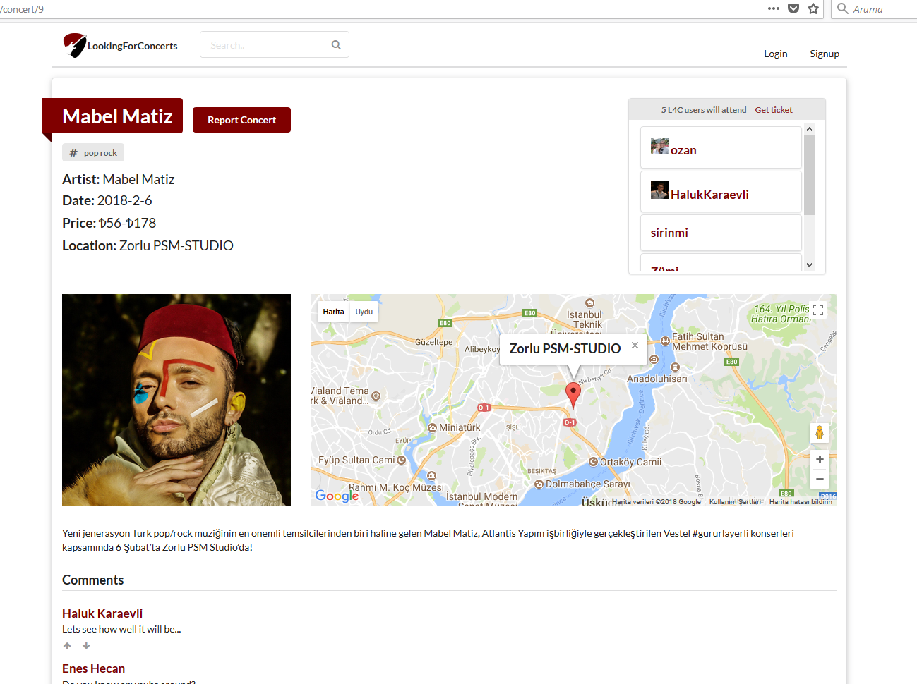

**e- User Page**

The user can view another user’s page by clicking on them on the concert page. The concerts the user attends, followers and followed users are displayed on this page.

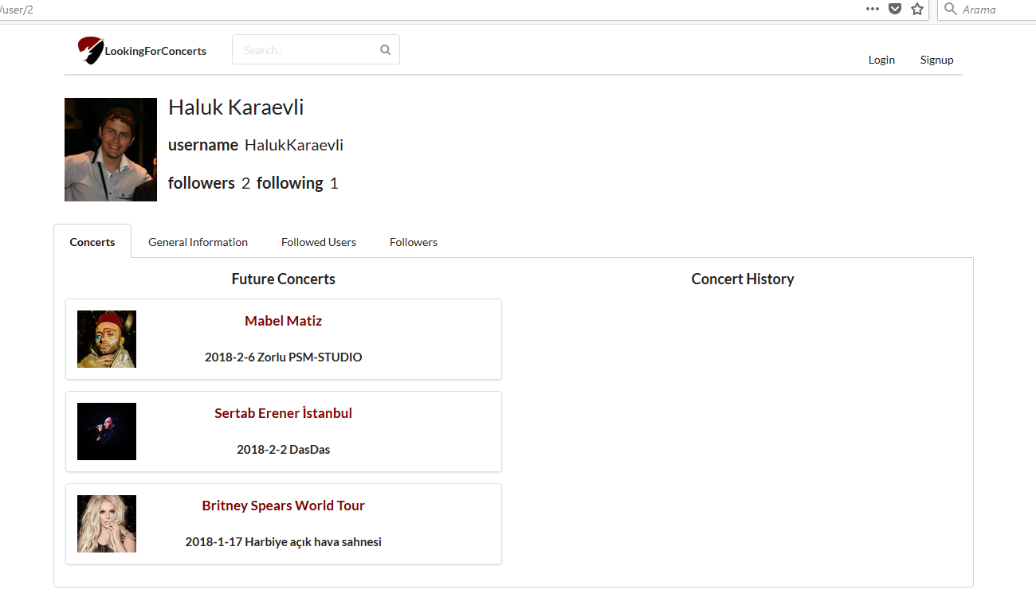

1. **Registered user**

**a- Homepage**

After logging in, the user can see all concerts or recommended concerts, create a concert, view own profile or logout on the home page.

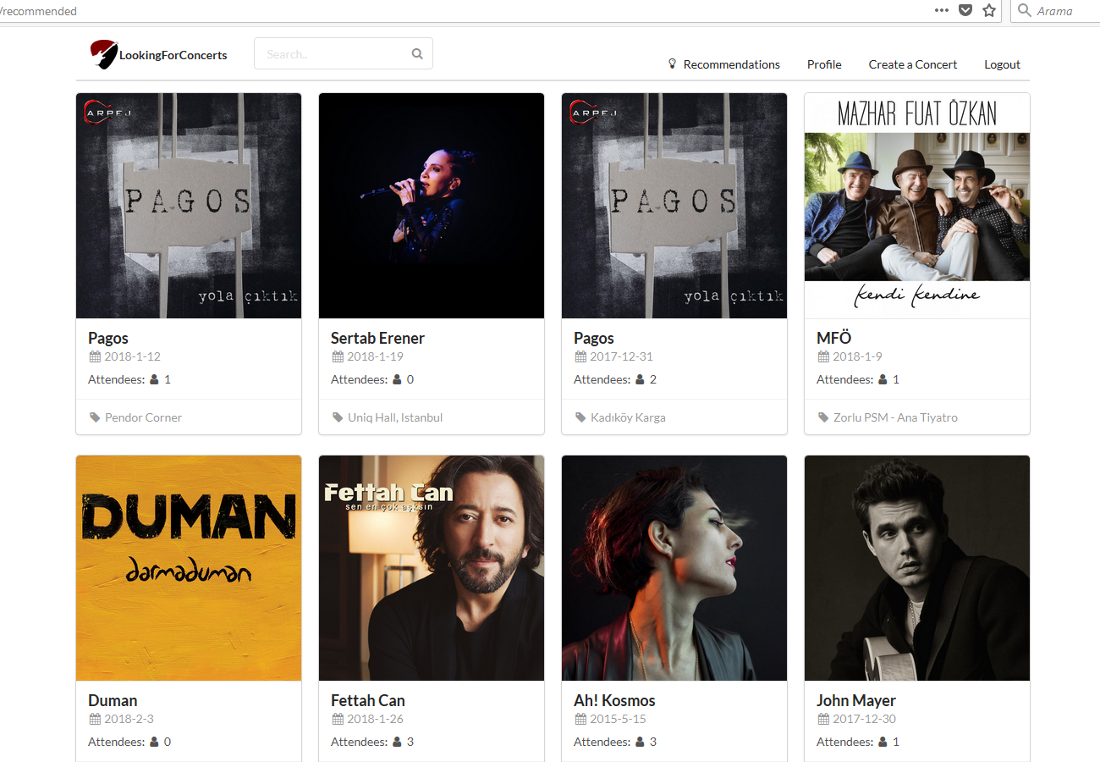

**b- Concert page**

A logged in user can comment on a concert, report a concert, mark a concert as attended and rank a concert after attending.

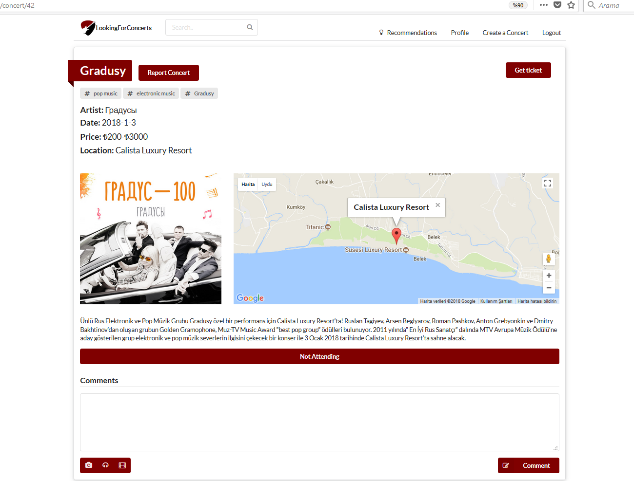

**c- User page**

A user can follow, unfollow another user or report the other user.

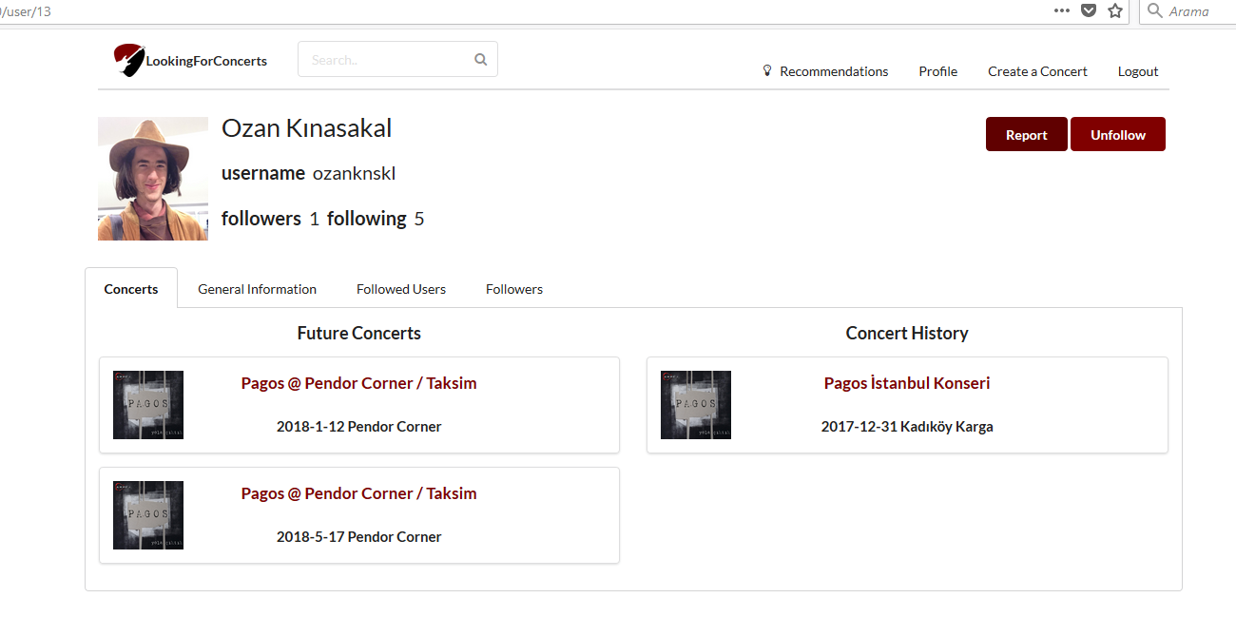

**d- Create a concert page**

The user can create a concert by filling out the form. To select an artist or tags first a search string needs to entered and the list button needs to be pressed. Then the user can select from the list. Also a location needs to be set. The user can write the address and press set location button to see if the location was correctly found.

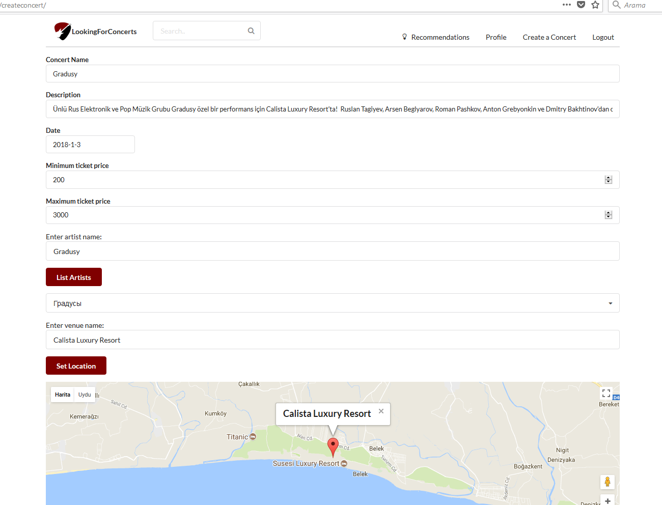

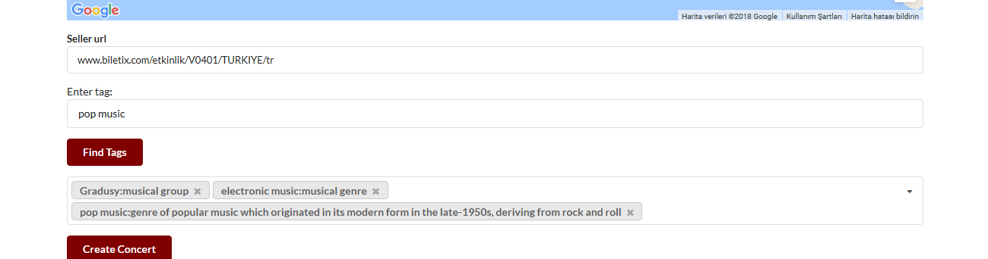

**e- Edit profile page**

The user can change their profile information by clicking edit on own profile page.

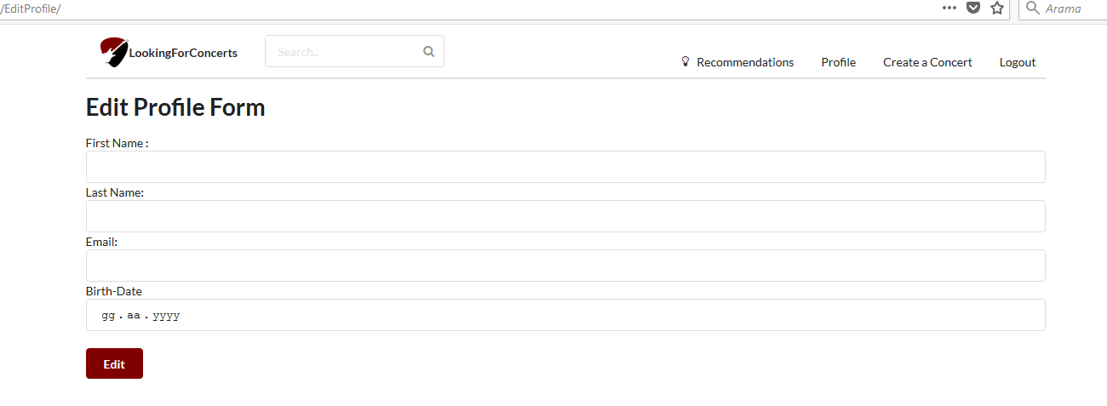

**f- Report a concert page**

A user can report a false information about a concert, list current reports, upvote reports and cancel their own report.

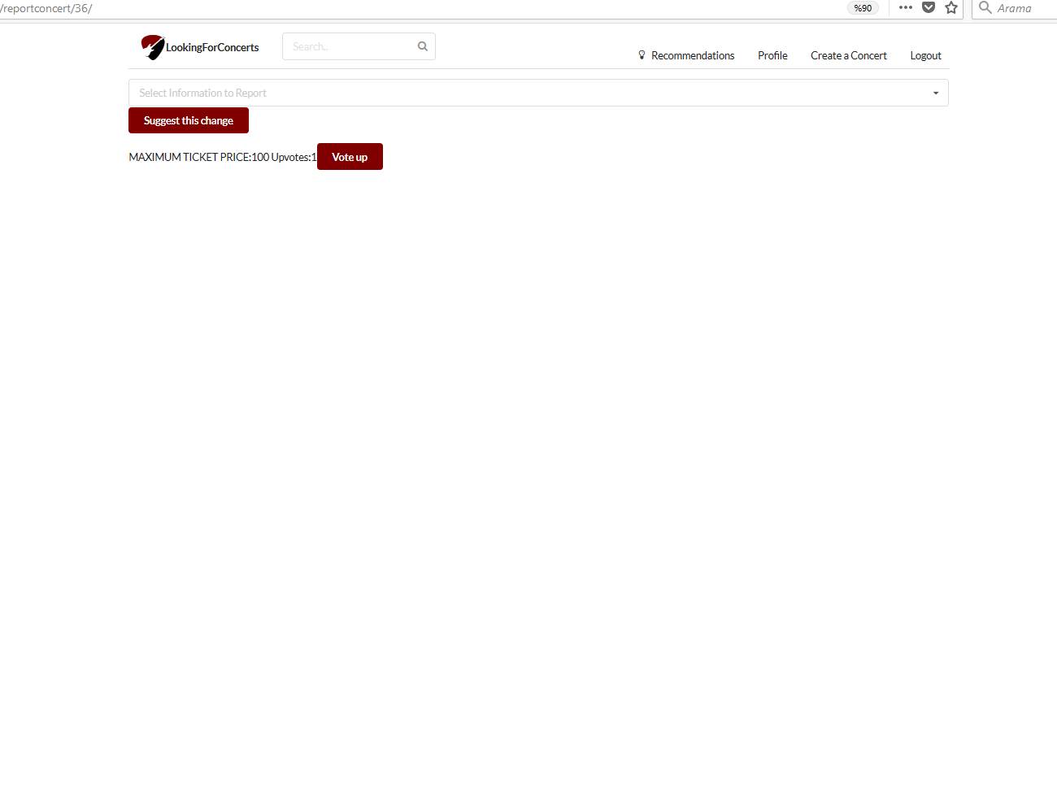

**g- User’s own page**

The user can here edit their profile photo, connect their Spotify account.

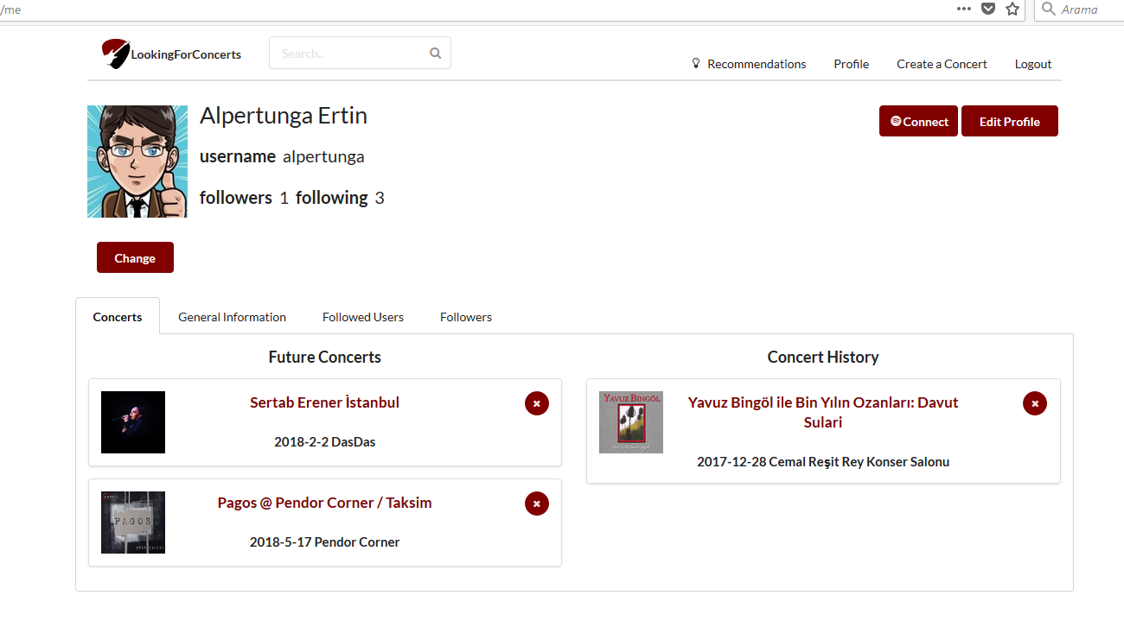

1. **Android application guide**